initramfs file missing or corrupted in CentOS 7 / RHEL 7

Create an issue
Become root
cd /boot
ll
rm initramfs-3.10.0-1160.e17.x86_64.img
y
ll
init 6

initramfs file missed or corrupted then getting kernel panic error as shown in the image below

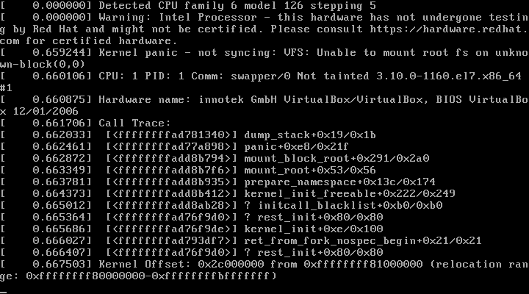

Reset OS through VM
Press Enter on rescue mode

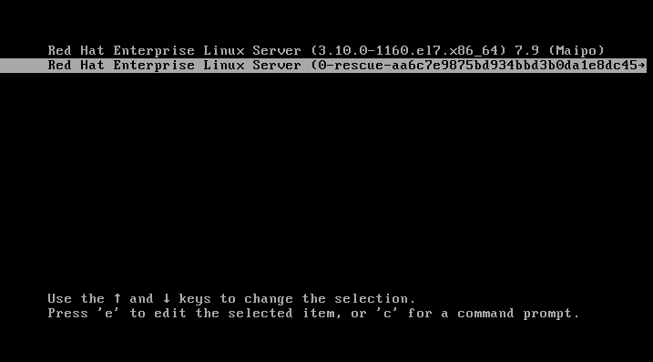

Login and become root in rescue mode

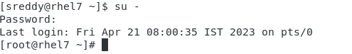

cd /boot
ll (If corrupted as shown in the image below)

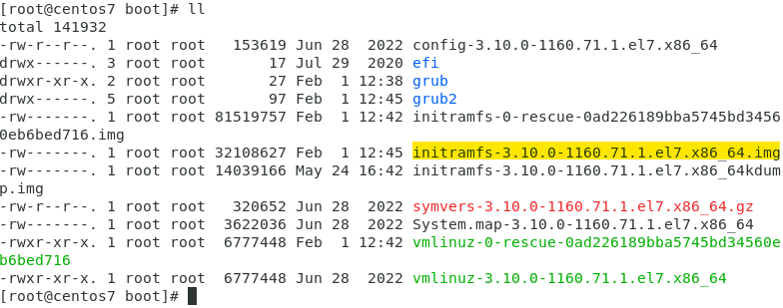

cd /boot
ll (If missed as shown in the image below)

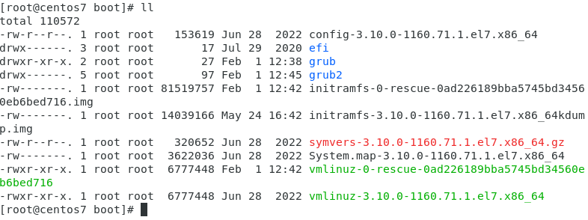

uname -r

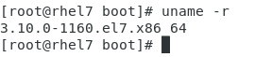

If initramfs missed then choose and execute 1 of 3 commands given below.
(Note: 3 commands are same functionality)

dracut initramfs-3.10.0-1160.el7.x86_64.img 3.10.0-1160.el7.x86_64 dracut initramfs-3.10.0-1160.el7.x86_64.img $(uname -r) dracut initramfs-$(uname -r).img $(uname -r)

If initramfs corrupted then choose and execute 1 of 3 commands given below.
(Note: 3 commands are same functionality)

dracut -f initramfs-3.10.0-1160.el7.x86_64.img 3.10.0-1160.el7.x86_64
dracut -f initramfs-3.10.0-1160.el7.x86_64.img $(uname -r)
dracut -f initramfs-$(uname -r).img $(uname -r)
ll
(Find initramfs file highlighted with yellow colour as shown in the image below)

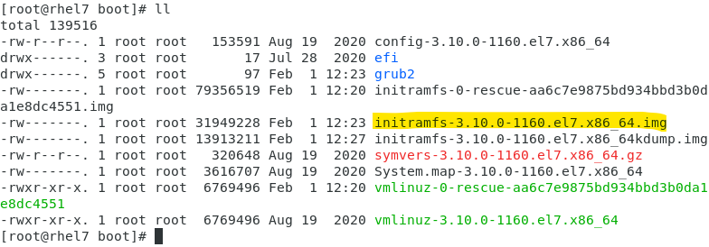

init 6
Press Enter on normal mode

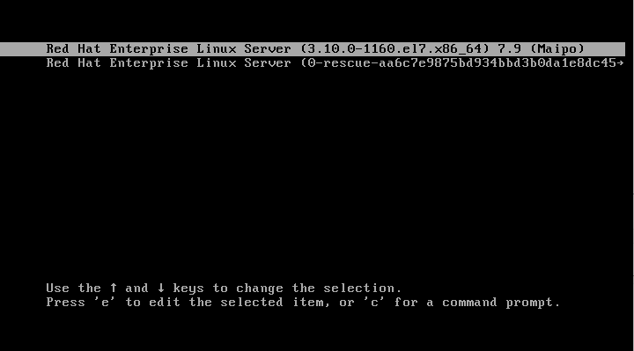

The system is started booting up without any issue

